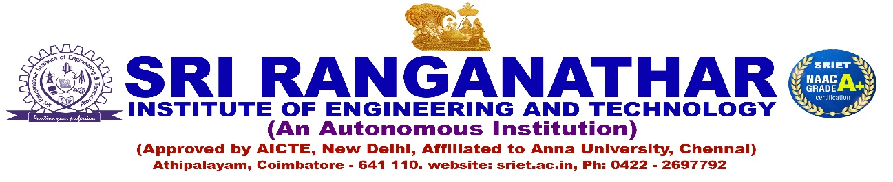
DEPARTMENT OF ELECTRICAL AND ELECTRONICS ENGINEERING
Memorandum of understanding

S. No | Organization with which MoU is Signed | Year of signing MoU | Duration
1 | Unique MEP Engineering Private Limited, Coimbatore | 2025-2026 | 3 Years
2 | IPCS Global Solutions Pvt Ltd, Coimbatore | 2024-2025 | 3 Years
3 | Power Integrated Solutions, Trichy | 2023-2024 | 3 Years
4 | I – Bacus - Tech | 2023-2024 | 3 Years
5 | Triox Technology, Coimbatore | 2021-2022 | 3 Years
6 | Sundrop Solutions, Chennai | 2021-2022 | 2 Years
7 | Novitech R&D Pvt. Ltd, Coimbatore | 2021-2022 | 2 Years
8 | S&G Innovators, Mettupalayam | 2019-2020 | 3 Years
9 | Good Will Systems, Coimbatore | 2019-2020 | 3 Years
10 | Mas Solar System Pvt, Ltd, Coimbatore | 2019-2020 | 2 Years

